**Exercise 1.1**

**1. Refrigerators**

|  |
| --- |
| Refrigerator |
| * Type =String * Colour = String * Feature = String |
| + Keeping Cool () = void  + Keep food safe () = void  + Store the food () = void |

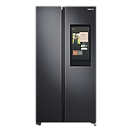

|  |
| --- |
| Side-by-Side |
| * Type = Side-by-Side * Colour = Black * Feature = Family Hub |
| + Keeping Cool () = void  + Keep food safe () = void  + Store the food () = void |

Example State

Example Method

**2. Tablets**

|  |
| --- |
| Tablets |
| * Brand = String * Type = String * Memory = int * Colour = String |
| + Youtube (Boolean watch) = void  + Take picture () = void  + Notification () = void |

|  |
| --- |
| Huawei |
| * Brand: Samsung * Type: Samsung Galaxy Tab A7 * Memory: 32GB+3GB * Colour: Silver |
| + Youtube (Boolean watch) = void  + Take picture () = void  + Notification () = void |

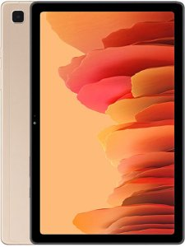

Example State

Example Method

**3. Earphone**

|  |
| --- |
| Earphone |
| * Brand = String * Type = String * Feature = String * Connection = String |
| + Listen to the music () = void  + Calling(Boolean speak) = void |

|  |
| --- |
| Huawei FreeLace |
| * Brand: HUAWEI FreeLace Amber Sunrise * Type: Wireless Earphone * Features: Memory Metal Cable Fit and Flexible * Connection: Bluetooth |
| + Listen to the music () = void  + Calling(Boolean speak) = void |

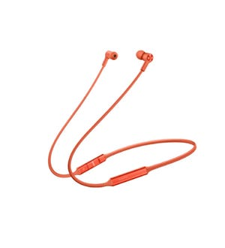

Example State

Example Method

**4. Air-Conditioner**

|  |
| --- |
| Air-Conditioner |
| * Brand = String * Type = String * Features = String |
| + Cool place(Boolean sleep) = void  + Less insects and parasites() = void  + Reduces the risk of Dehydration () = void |

|  |
| --- |
| Panasonic |
| * Brand: Panasonic * Type: CS-U13VKH 1.5HP Premium Inverter Aero Series * Features: Fast cooling |
| + Cool place(Boolean sleep) = void  + Less insects and parasites() = void  + Reduces the risk of Dehydration () = void |

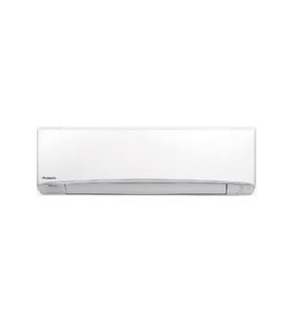

Example State

Example Method

**5. Chicken**

|  |
| --- |
| Chicken |
| * Breed = String * Size = Char * Colour = String |
| + Eating () = void  + Laying eggs() = void  + Running () = void |

|  |
| --- |
| ISA Brown |
| * Breed: ISA Brown * Size: Medium * Colour: Black & White |
| + Eating () = void  + Laying eggs() = void  + Running () = void |

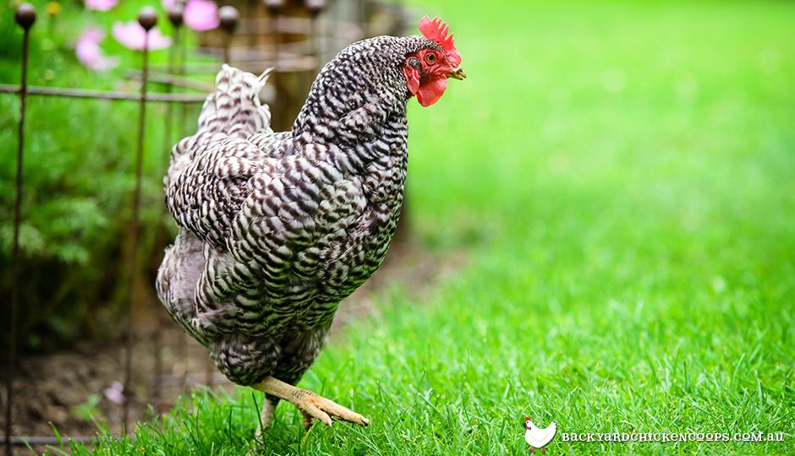

Example Method

Example State